**Semester 1 (Unit 3) Examination, 2018**

**Question/Answer Booklet**

**MATHEMATICS APPLICATIONS**

**Section Two: Calculator-assumed**

Student Name/Number: ______________________________________________

Teacher Name: ______________________________________________

**Time allowed for this section**

Reading time before commencing work: ten minutes

Working time for this section: one hundred minutes

**Materials required/recommended for this section**

**To be provided by the supervisor:** This Question/Answer Booklet

Formula Sheet (retained from Section One)

**To be provided by the candidate:**

Standard items: pens (blue/black preferred), pencils (including coloured), sharpener,

correction fluid/tape, eraser, ruler, highlighters

Special items: drawing instruments, templates, notes on 2 unfolded sheets of A4 paper, and up to three calculators approved for use in the WACE examinations

**Important note to candidates**

No other items may be taken into the examination room. It is **your** responsibility to ensure that you do not have any unauthorised notes or other items of a non-personal nature in the examination room. If you have any unauthorised material with you, hand it to the supervisor **before** reading any further.

**Structure of this paper**

|  |  |  |  |  |  |
| --- | --- | --- | --- | --- | --- |
| Section | Number of questions available | Number of questions to be answered | Working time (minutes) | Marks available | Percentage of exam |
| Section One: Calculator-free | 6 | 6 | 50 | 50 | 35 |
| Section Two: Calculator-assumed | 11 | 11 | 100 | 100 | 65 |
|  | | | | | 100 |

**Instructions to candidates**

1. The rules for the conduct of School exams are detailed in the *College assessment policy*. Sitting this examination implies that you agree to abide by these rules.
2. Write your answers in this Question/Answer Booklet.

3. You must be careful to confine your responses to the specific questions asked and to follow any instructions that are specific to a particular question.

1. Supplementary pages for the use of planning/continuing your answer to a question have been provided at the end of this Question/Answer booklet. If you use these pages to continue an answer, indicate at the original answer where the answer is continued, i.e. give the page number.
2. Show all working clearly**.** Your working should be in sufficient detail to allow your answers to be checked readily and for marks to be awarded for reasoning. Incorrect answers given without supporting reasoning cannot be allocated any marks. For any question or part question worth more than two marks, valid working or justification is required to receive full marks. If you repeat any question, ensure that you cancel the answer you do not wish to have marked.
3. It is recommended that you do not use pencil, except in diagrams.
4. The Formula Sheet is not to be handed in with your Question/Answer Booklet.

**Section Two: Calculator-assumed 65% (100 Marks)**

This section has 11 questions. Answer **all** questions. Write your answers in the spaces provided.

Supplementary pages for the use of planning/continuing your answer to a question have been provided at the end of this Question/Answer booklet. If you use these pages to continue an answer, indicate at the original answer where the answer is continued, i.e. give the page number.

Working time: 100minutes.

**Question 7 (5 marks)**

The table below shows data for each state and territory in Australia. The overall numbers of people migrating overseas and the increase in population in one particular year, both recorded in thousands, are the variables indicated.

|  |  |  |  |  |  |  |  |  |
| --- | --- | --- | --- | --- | --- | --- | --- | --- |
|  | NT | TAS | ACT | SA | WA | QLD | VIC | NSW |
| **Net overseas migration** | 0.4 | 1 | 1.6 | 9 | 13 | 20 | 65 | 71 |
| **Population increase** | 0.4 | 3.3 | 6.8 | 10.5 | 21.4 | 80 | 144 | 121 |

(a) Describe the association that exists between these two variables. (1 mark)

(b) Does the change that occurs in the values of one of the variables cause changes to the values of the other variable? Explain your conclusion. (2 marks)

(c) A possible explanation for the association between these two variables is **confounding due to a common response to another variable.** Explain what is meant by “confounding” and identify a possible third variable to which these two given variables are responding. (2 marks)

**Question 8 (8 marks)**

Town planners in two suburbs, Fland and Klind are planning to increase the lengths of dedicated bike paths. In Fland there were 10 km of bike paths at the end of the first week and these were scheduled to increase by 0.4 km each week.

(a) Determine a recurrence relation to describe the growth in the length of bike paths in Fland. (2 marks)

(b) When will the lengths of bike paths reach 20 km in Fland? (2 marks)

In Klind the rule to determine the length of bike paths after *n* weeks was given by



(c) In which suburb was there a greater rate of growth in the lengths of dedicated bike paths? Justify your conclusion. (2 marks)

(d) After a number of weeks the lengths of bike paths in each suburb will be the same. When will the lengths be the same? Show how you determined your answer.

(2 marks)

**Question 9 (7 marks)**

Buses travel from:

* the railway station (R) to the university (U)
* the railway station to the shopping forum (F)
* the forum to the netball (N) centre
* the city (C) to the forum
* the city to the university and back along the same route
* the railway station to the hospital (H) and back along the same route
* the city to the show grounds (S) and back along the same route
* the railway station to the show grounds and back along the same route
* the show grounds to the hospital
* the university to the hospital

(a) Draw the network which represents the bus routes between locations as described. Use the vertices provided. Indicate the directions the bus travels on your diagram. (3 marks)

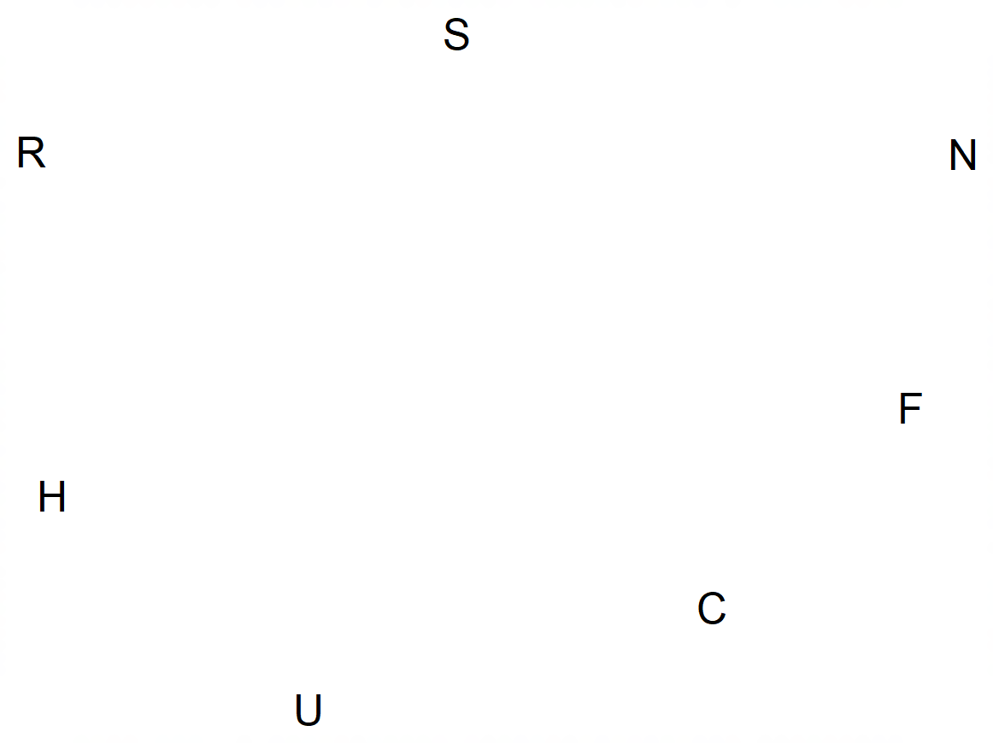

(b) Identify the route which forms a bridge. Explain your selection. (2 marks)

(c) Is your graph planar? Explain. (2 marks)

**Question 10 (13 marks)**

The table below shows three measures of thermal comfort for 12 different weather stations in Western Australia. All readings were taken at the same time on the same day. The measures are

* Wet bulb globe temperature (WBGT)
* Apparent temperature (AT)
* Relative humidity (RH)

|  |  |  |  |  |  |  |  |  |  |  |  |  |
| --- | --- | --- | --- | --- | --- | --- | --- | --- | --- | --- | --- | --- |
| Station | 1 | 2 | 3 | 4 | 5 | 6 | 7 | 8 | 9 | 10 | 11 | 12 |
| AT | 20.7 | 35.0 | 28.2 | 33.2 | 26.6 | 26.4 | 35.8 | 28.0 | 22.6 | 28.7 | 30.6 | 30.1 |
|  | | | | | | | | | | | | |
| WBGT | 19.3 | 26.6 | 23.0 | 28.1 | 20.9 | 21.5 | 28.5 | 22.4 | 21.2 | 25.5 | 25.6 | 26.1 |
|  | | | | | | | | | | | | |
| RH | 65 | 55 | 25 | 65 | 30 | 45 | 60 | 35 | 45 | 75 | 75 | 85 |

The graph below shows a scatter plot for two of these variables.

(a) Describe the relationship between WBGT and AT in terms of form, direction and strength. (3 marks)

(b) If the WBGT is influenced by the change in the AT would it be classified as the explanatory or the response variable? (1 mark)

(c) For the relationship between WGBT and AT determine

(i) the equation for the least squares line (2 marks)

(ii) the correlation coefficient (1 mark)

(d) Predict the WBGT when the Apparent Temperature is 25 degrees. (1 mark)

(e) How reliable is the prediction made in part (d). Give TWO reasons to justify your conclusion. (3 marks)

(f) The graph below shows the relationship between relative humidity and WBGT.

For this relationship compared to the one between AT and WBGT;

(i) is the correlation coefficient greater or smaller? (1 mark)

(ii) is the gradient of the least squares line greater or smaller? (1 mark)

**Question 11 (11 marks)**

Students studying different populations of tigers and rhinos estimated the rules governing the numbers in each population every ten years.

Rhinos: The rule is  and the population is shown on the graph below.

Tigers: The rule is 

For both animals, *n* represents the number of 10-year periods (decades) since 1970. Only the data for every 10 years (and not the years between) were considered.

(a) Describe the change in the population of rhinos between 1980 and 2020.

(2 marks)

(b) Complete the table below by entering the estimated tiger population from 1980 to 2020. (2 marks) (2 marks)

|  |  |  |  |  |  |
| --- | --- | --- | --- | --- | --- |
| Year | 1980 | 1990 | 2000 | 2010 | 2020 |
| Population |  |  |  |  |  |

(c) On the axes above, graph the tiger population at each ten-year period from 1980 to 2020. (2 marks)

(d) It is believed that the tigers will die out if the population goes below 20. By which year is this likely to occur? (2 marks)

(e) For the populations of the two animals:

(i) Which population is changing at the more rapid rate? (1 mark)

(ii) Which population loses the most animals in the first 10 years? (1 mark)

(iii) For which of these populations can the change in numbers be described as geometric? (1 mark)

**Question 12 (11 marks)**

(a) The following planar graphs all have 5 vertices but the numbers of faces and edges are not the same.

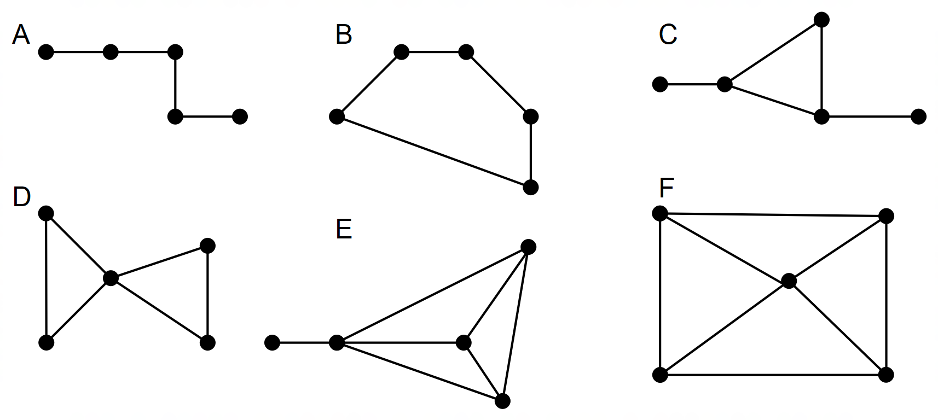

(i) Explain why they can all be described as planar. (1 mark)

(ii) By completing the following table, show that Euler’s ruler works for graphs A to F.

(5 marks)

|  |  |  |  |
| --- | --- | --- | --- |
| Number of vertices  (*v*) | Number of edges  (*e*) | Number of faces  (*f*) | *v* + *f* - *e* |
|  |  |  |  |
|  |  |  |  |
|  |  |  |  |
|  |  |  |  |
|  |  |  |  |
|  |  |  |  |

(b) Consider the following graph

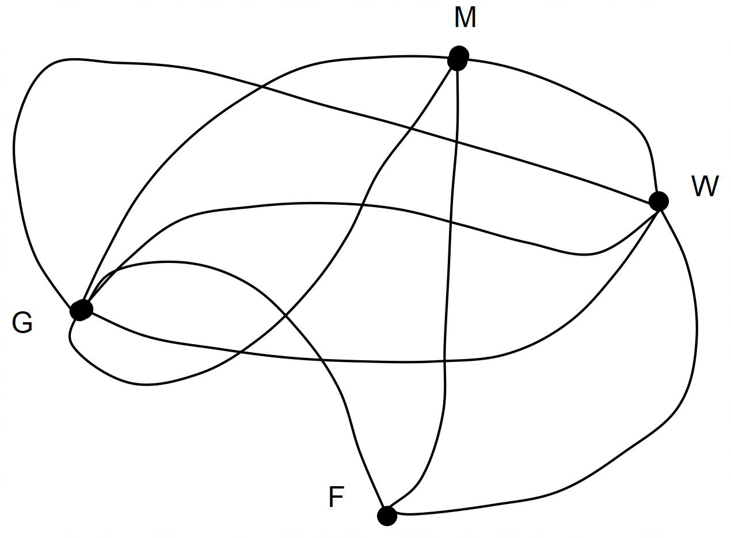

(i) Give one reason to justify why this graph is not a simple graph. (1 mark)

(ii) Which vertex has the highest degree? (1 mark)

(iii) Redraw the graph in planar form. Use the vertices provided. (3 marks)

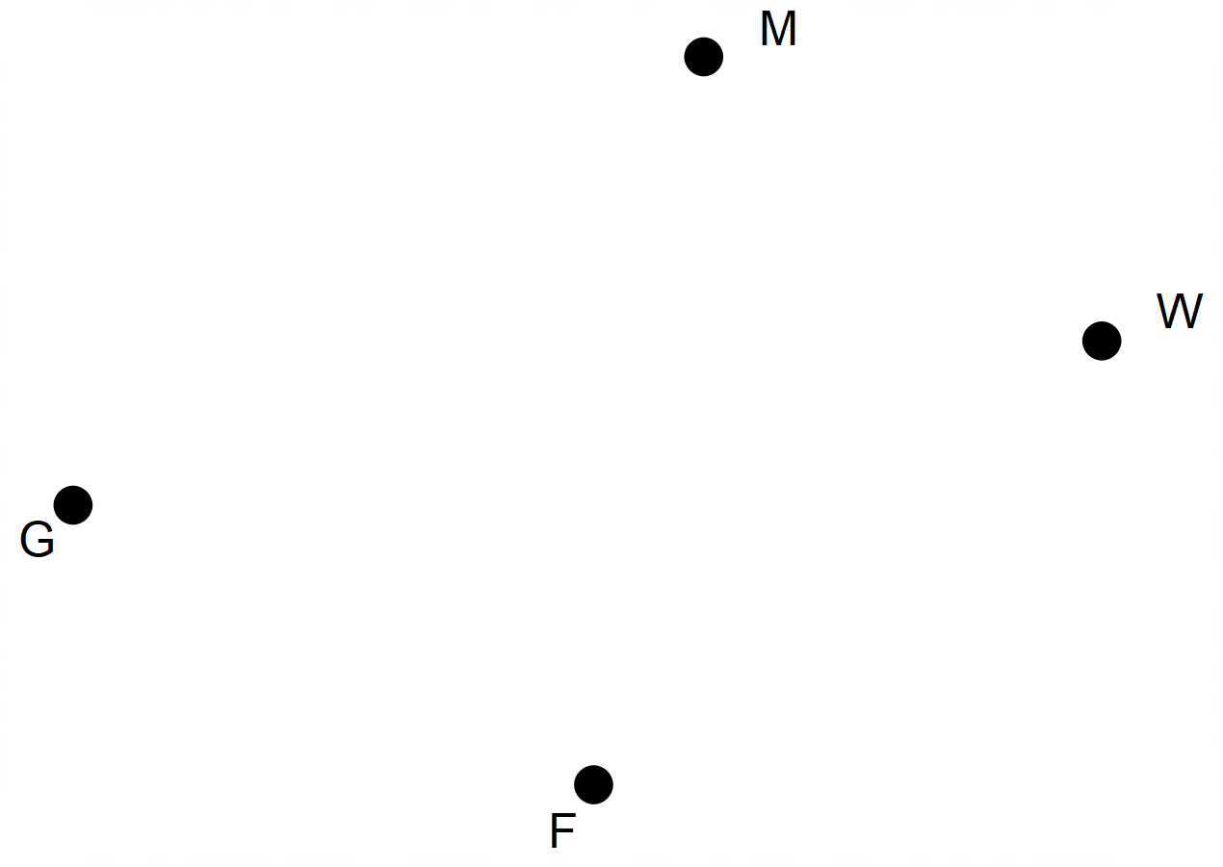

**Question 13 (8 marks)**

Local residents were asked to vote for **one** of the three options which described possible improvements to the dog park in their suburb.

The results showing the numbers of people voting for each option are summarised below.

|  |  |  |  |  |
| --- | --- | --- | --- | --- |
|  | Option 1 | Option 2 | Option 3 | Total |
| Male owning a dog | 43 | 24 | 53 | 120 |
| Male not owning a dog | 21 | 9 | 30 | 60 |
| Female owning a dog | 60 | 40 | 50 | 150 |
| Female not owning a dog | 42 | 18 | 30 | 90 |
| Total | 142 | 115 | 163 |  |

(a) How many people in total voted? (1 mark)

(b) Name two categorical variables identified in this survey.

(2 marks)

(c) Complete the table below. It shows the percentages of voters in each category.

Values are rounded to the nearest integer and the total is 100%. (2 marks)

|  |  |  |  |  |
| --- | --- | --- | --- | --- |
|  | Option 1 | Option 2 | Option 3 | Total |
| Male owning a dog | 36 | 20 | 44 | 100 |
| Male not owning a dog |  |  |  | 100 |
| Female owning a dog | 40 | 27 | 33 | 100 |
| Female not owning a dog | 47 | 20 | 33 | 100 |

(d) Use the data in the table to determine and to describe one association between the variables. Explain your reasoning. (2 marks)

(e) Before an association can be confirmed, data are converted to percentages. Explain why this is necessary. (1 mark)

**Question 14 (10 marks)**

The first five numbers of two sequences are given in the table below.

|  |  |  |  |  |  |
| --- | --- | --- | --- | --- | --- |
| Term number | 1 | 2 | 3 | 4 | 5 |
| *A* | 12 | 13.4 | 14.8 | 16.2 | 17.6 |
| *B* | 4 | 4.6 | 5.29 | 6.0835 | 6.996025 |

(a) What type of sequence is sequence *A*? (1 mark)

(b) Determine the rule for the *nth*term of sequence *A*. (2 marks)

(c) Use your rule from part (b) to determine *A*10 (2 marks)

(d) Write the rule that can be used to determine *Bn+1*when given *Bn*. (1 mark)

(e) At what value of *n* will the sequence *An* first exceed 100? (2 marks)

(f) At what value of *n* are the two sequences closest in value. Justify your decision. (2 marks)

**Question 15 (10 marks)**

The graph below represents the places that Pat visited in the shopping centre and the pathways linking these places.

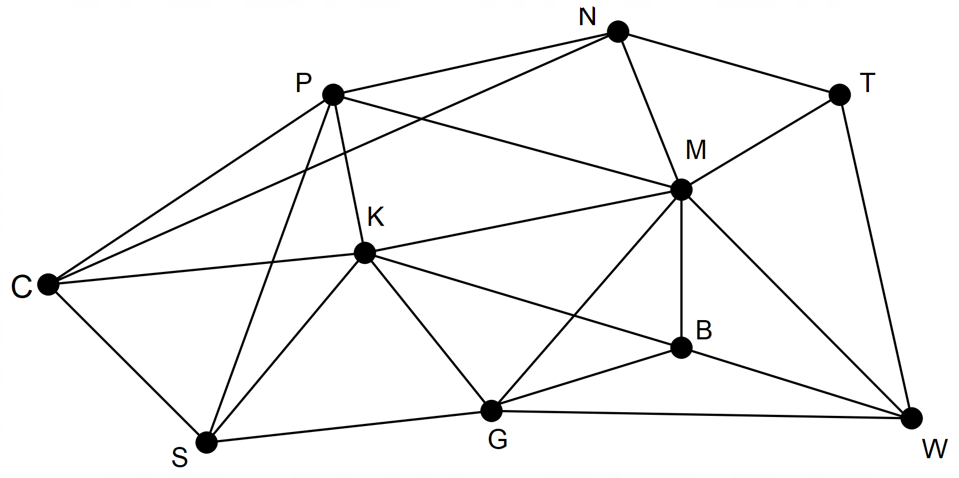

Pat went to these places in the following order from the car park at C: CPMNTWGBKSC

(a) Mark Pat’s route on the network above. (1 mark)

(b) Is the network an example of a complete graph? Justify your conclusion. (2 marks)

(c) Pat’s route is referred to as a cycle? Give THREE reasons for this conclusion.

(3 marks)

(d) Name the type of cycle formed by Pat’s route. (1 mark)

(e) Pat’s route is also a closed walk. What is the length of Pat’s walk? (1 mark)

(f) Pat started and ended at the car park (C) and wanted to visit the pharmacist (P) first and the supermarket (S) last. Name another route that could have been used **and** draw it on the diagram below. (2 marks)



**Question 16 (9 marks)**

The following connected graph shows eight different tourist destinations and the connections (edges) available to travel from one to destination to another.

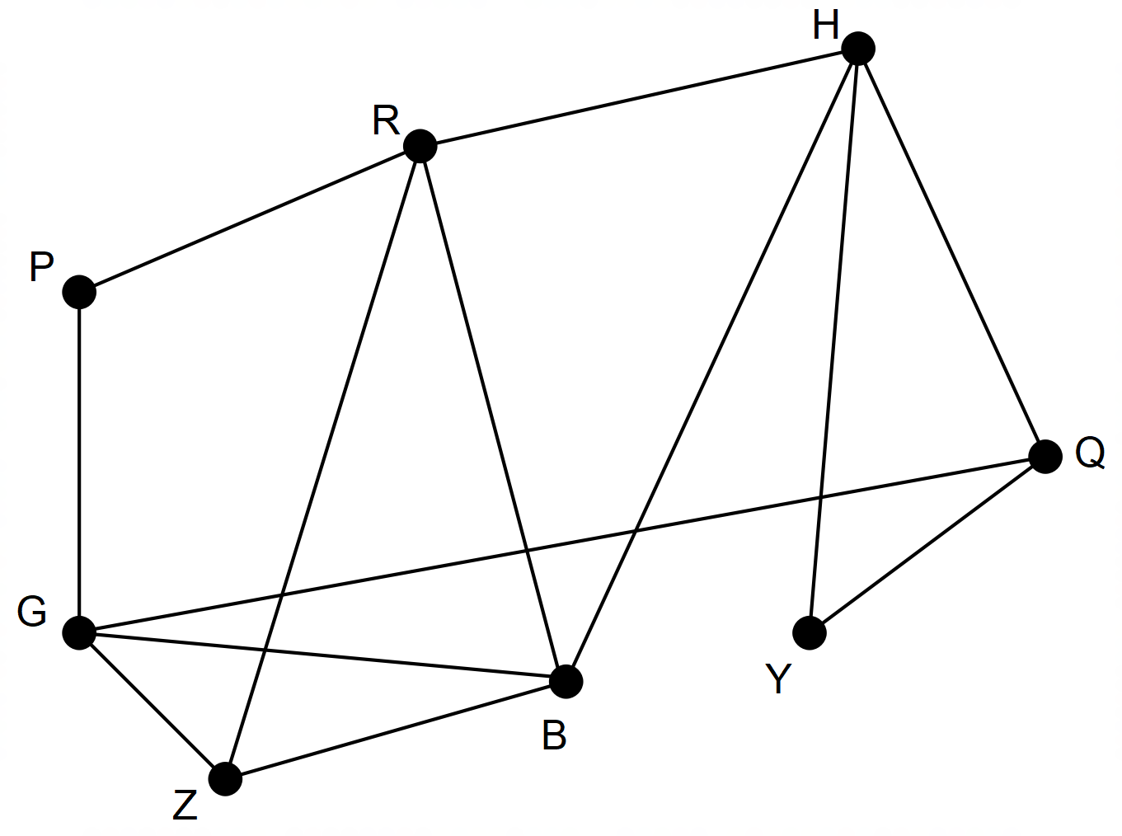

(a) The sub-graph GPR can be classified as an open trail. Explain this classification.

(2 marks)

(b) Identify a route that could be used to travel to all destinations, along all connections but without repeating any of the connections. List the vertices in order of travel. (3 marks)

(c) Is the graph Eulerian or semi-Eulerian? Explain. (3 marks)

(d) Another tourist destination and its connections are to be added to the graph. The destinations will still need to be travelled without repeating any connections. What is a necessary feature of the new vertex and its connections? (1 mark)

**Question 17 (8 marks)**

The sizes and costs of 8 chest freezers have been located on a Warehouse website.

The equation for the line describing the relationship between these two variables is:

Predicted Cost = Size x 1.2052 + 138.61

The equation was used to determine the predicted cost for the eight freezers.

The coefficient of determination was given as 0.9927.

|  |  |  |  |  |  |  |  |  |
| --- | --- | --- | --- | --- | --- | --- | --- | --- |
| Size (L) | 143 | 200 | 200 | 260 | 290 | 324 | 384 | 519 |
| Actual Cost ($) | 300 | 370 | 375 | 460 | 500 | 550 | 600 | 750 |
| Predicted cost | 311 | 380 | 380 | 452 | 488 | 529 | 601 | 764 |
| Residuals |  |  |  |  |  |  |  |  |

(a) What percentage of the change in the cost is attributed to the change in the size of the freezer? (1 mark)

(b) Complete the table by entering the residuals into the fourth row. (2 marks)

(c) Draw the residual plot on the axes below. (4 marks)

Residual

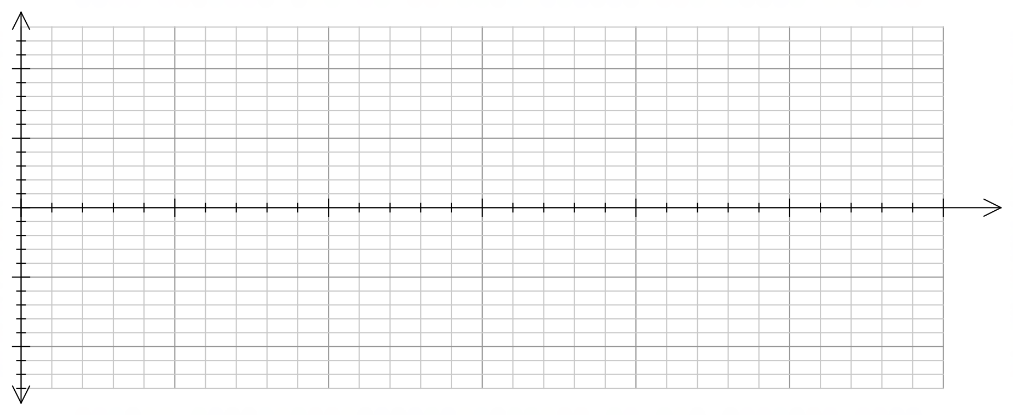

Size (L)

(d) What feature of the residual plot suggests that a linear model is an appropriate representation of the relationship between size and cost? (1 mark)

**End of Questions**

Additional working space

Question number: __________________

Additional working space

Question number: __________________

**Acknowledgements**

Data for Question 7 were sourced from the website for the Australian Bureau of Statistics.

Data for Question 11 was estimated from the World Wildlife website.

© MAWA, 2018

This examination is Copyright but may be freely used within the school that purchases this licence.

* The items that are contained in this examination are to be used solely in the school for which they are purchased.
* They are not to be shared in any manner with a school which has not purchased their own licence.
* The items and the solutions/marking keys are to be kept confidentially and not copied or made available to anyone who is not a teacher at the school. Teachers may give feedback to students in the form of showing them how the work is marked but students are not to retain a copy of the paper or marking guide until the agreed release date stipulated in the purchasing agreement/licence.

*Published by The Mathematical Association of WA*

*12 Cobbler Place, MIRRABOOKA 6…*